Experiment-11

Change Hardware compatibility of a VM (Either by clone/create new one) which is already created and configured.

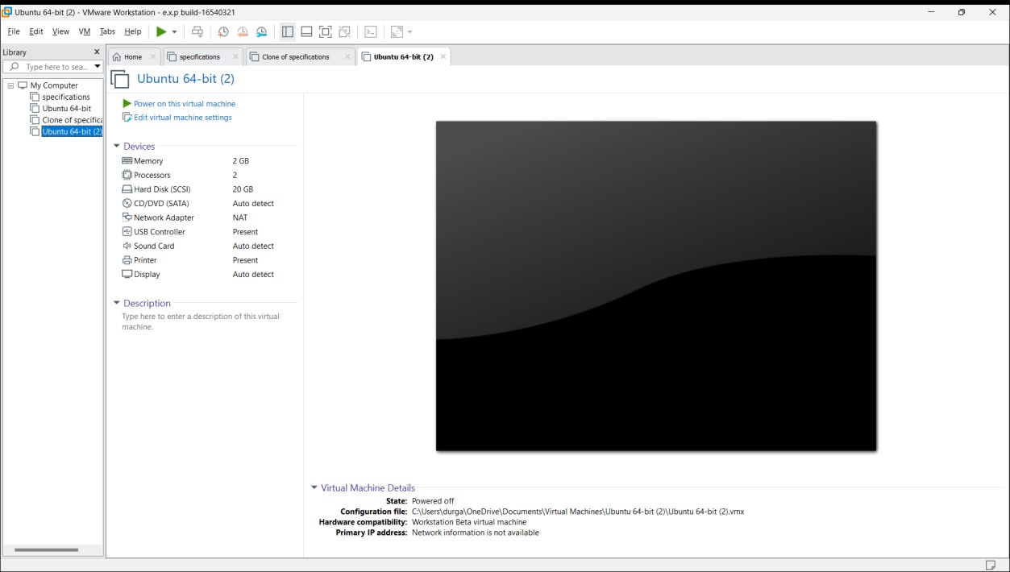

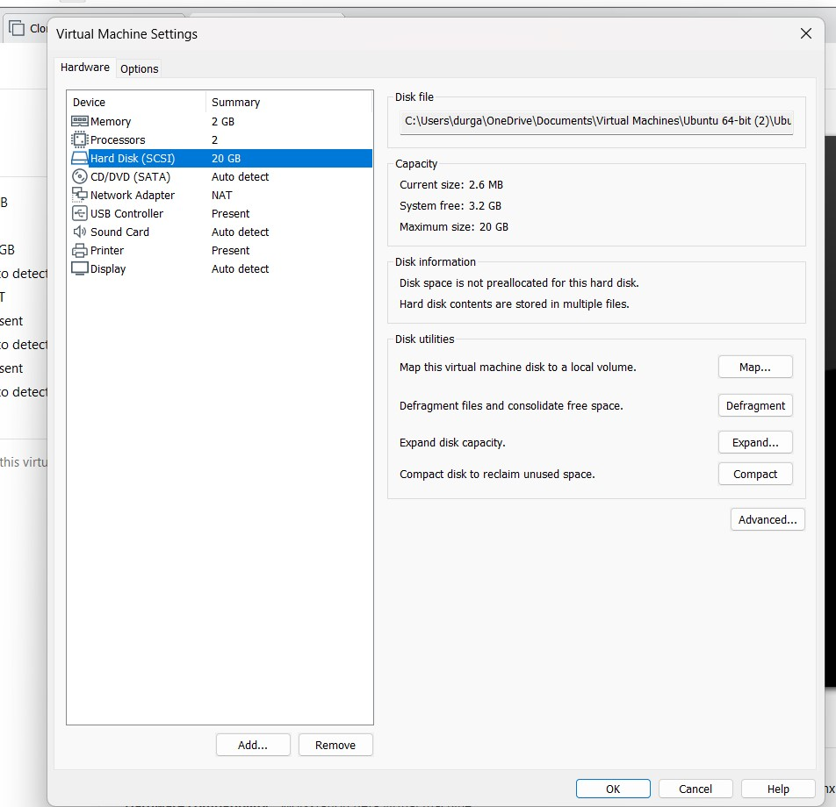

Ansar -19110287

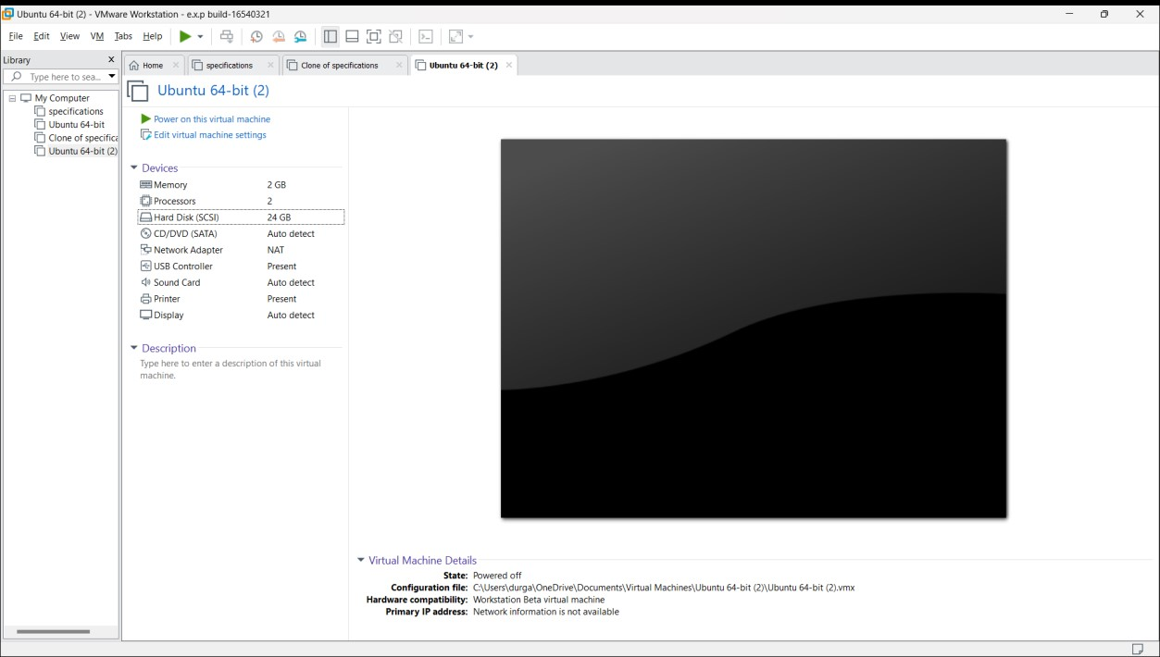

Ansar -19110287